**How to capture Perfmon data using the “my_disk_perfmon.bat” script.**30/5/2014.

**Introduction**The batch script “my_disk_perfmon.dat” creates a Windows Perfmon data collection set to capture performance data for each of the physical disk drives C, D, and E (if present). To run the script, the user needs to be a member of the local Administrators group.  
  
**Example usage (on Windows Server 2008 R2):**o Create a directory where the script can be run from, and where the output log files will be created. Copy the “my_disk_perfmon.bat” script, and related files, into this directory.   
For example:  
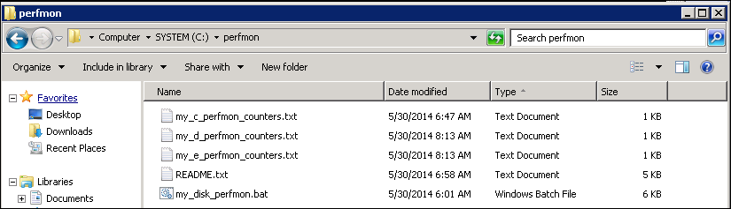  
  
o Run the “my_disk_perfmon.bat” script without any arguments, in order to see the usage:  
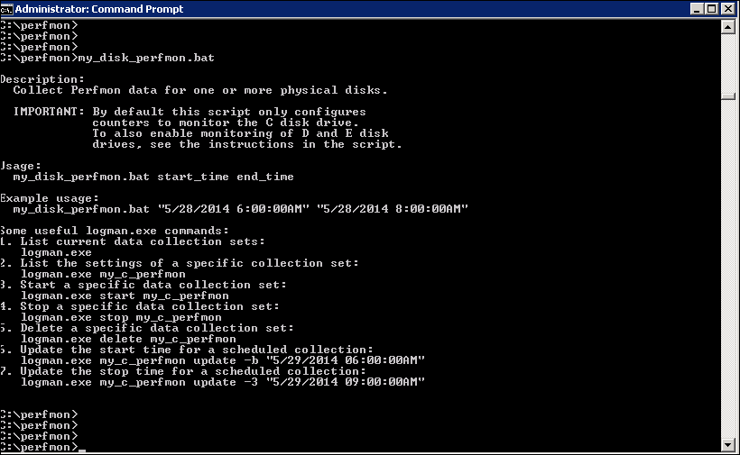  
  
o First check if there any existing data collection sets already configured:  
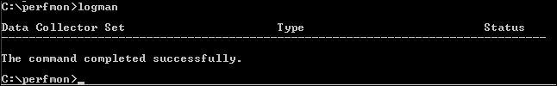  
 No, there aren’t any defined yet. If you need to stop or remove any, use the logman.exe “stop” and “delete” commands (see the usage output above).  
  
o Create our data collection sets for each disk and specify the scheduled start/stop times:  
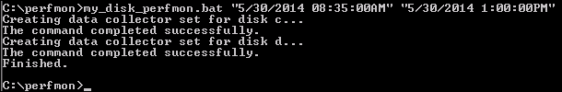  
**Note**: The data collection will start automatically at the specified time.  
**Note**: You need to edit the script in order to create data collection sets for the D and/or E drives.  
  
o Our data collection sets should now be listed:  
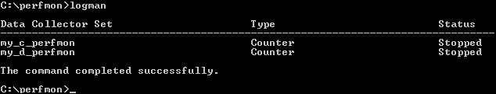  
  
o If you ever want to see the details for each data collection set:  
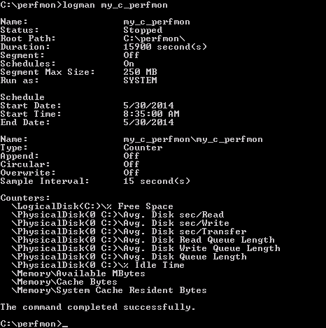  
**Note**: Those “Counters” are the ones defined in the external text file my_c_perfmon_counters.txt.  
**Note**: We never seem to see the End time in this output (just the date), however the “Duration” value confirms the end time that we used.  
  
o Examine the output CSV files once the data collection has completed.  
  
One way to do this is to use the output CSV file and generate Excel charts.  
The following steps describes how to do this:  
1. Open the CSV file in Excel and click the top-left cell to select all the data.  
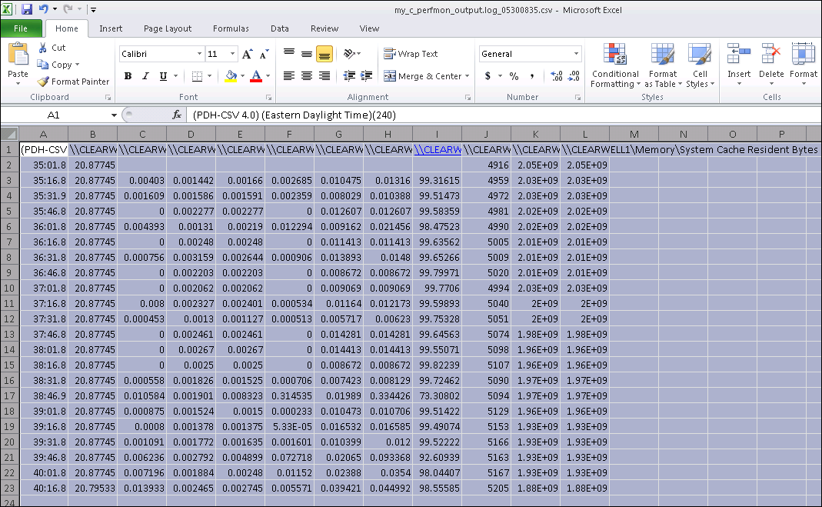

2. Go to “Insert”, select “Line” and then select a chart type:  
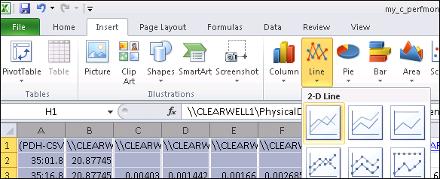  
  
You should now see something like the following:  
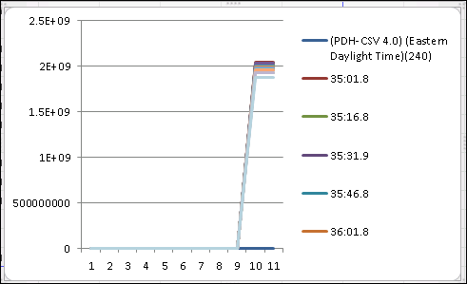

3. We need the first column (i.e. the time) to be the x-axis.   
To do this, right-click on the chart and select “Select Data…”.   
You should see the following:  
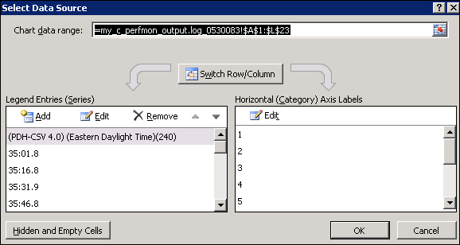  
  
Click “Switch Row/Column”. This will make the first column the X-axis:  
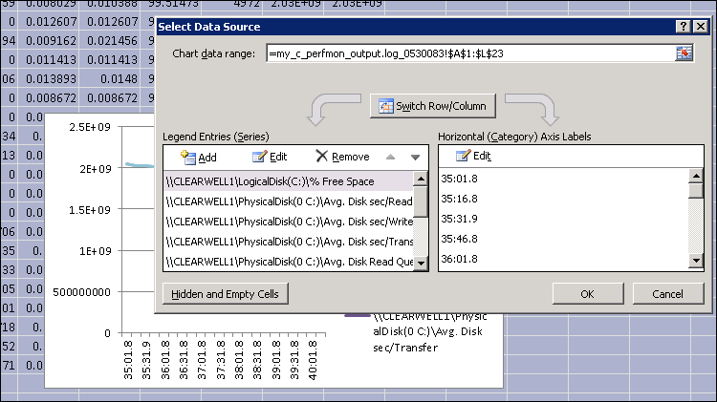

4. To make the chart more readable (because the column values range from very small numbers up to very large numbers), remove all the “Memory” columns and also the “Idle Time” column, and finally the “Free Space” column, using the “Remove” option. Then click the “OK” button. You should now see something a little more readable:  
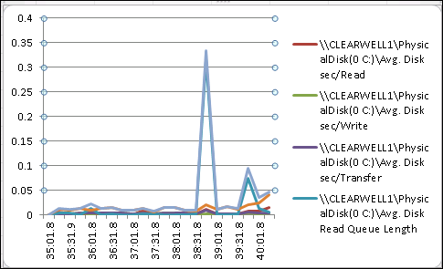  
  
JeremyC 30/5/2014.  
**END**